H.T No
Regulations:
A20

Sreenidhi Institute of Science and Technology
(An Autonomous Institution)
Code No:8B410 Date: 22-January -2025 (AN)

B.Tech II-Year II- Semester External Examination, January -2025 (Supplementary)
KINEMATICS OF MACHINERY (MECHANICAL)

Time: 3 Hours Max.Marks:70

Note: a) No additional answer sheets will be provided.
b) All sub-parts of a question must be answered at one place only, otherwise it will not be valued.
c) Missing data can be assumed suitably.

Bloom's Cognitive Levels of Learning (BCLL)

Remember | L1 | Apply | L3 | Evaluate | L5
Understand | L2 | Analyze | L4 | Create | L6

Part - A Max.Marks:20
Answer all QUESTIONS

 |  | BCLL | CO(s) | Marks
1 | Differentiate between a machine and a structure. | L1 | CO1 | [2M]
2 | What are the limitations of a single Hooke’s joint? | L1 | CO2 | [2M]
3 | Define Coriolis component of acceleration | L1 | CO3 | [2M]
4 | What is meant by lift or stroke in cam? | L1 | CO4 | [2M]
5 | Define the following terms related to gears  a. Back lash b. pressure angle | L1 | CO5 | [2M]
6 | What is centrifugal tension in a belt? How does it affect the power transmitted? | L2 | CO6 | [2M]
7 | Define Rubbing Velocity. | L1 | CO2 | [2M]
8 | What do you mean by straight line mechanisms and list the types | L1 | CO3 | [2M]
9 | Explain the Inverted gear train. | L2 | CO5 | [2M]
10 | Define following terms related to Cams  : (i) Prime Circle and (ii) pitch point | L1 | CO4 | [2M]
Part – B Max.Marks:50
ANSWER ANY FIVE QUESTIONS. EACH QUESTION CARRIES 10 MARKS.

 |  |  | BCLL | CO(s) | Marks
11. |  | Sketch and explain any two inversions of a double slider crank chain | L2 | CO1 | [10M]
12. |  | Locate all the instantaneous centers of the slider crank mechanism as shown in Fig.1. The lengths of crank OB and connecting rod AB are 100 mm and 400 mm respectively. If the crank rotates clockwise with an angular velocity of 10 rad/s, find: 1. Velocity of the slider A, and 2. Angular velocity of the connecting rod AB  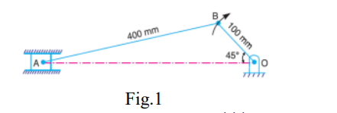 |  | CO2 | [10M]
13. | a) | With the help of sketch, describe Pantograph and give its applications | L2 | CO3 | [5M]
 | b) | Derive the condition for correct steering of an automobile? | L3 | CO3 | [5M]
14. |  | The following data relate to a cam profile in which the follower moves with uniform acceleration and deceleration during the ascent and the descent. Minimum radius of cam = 25mm, Roller diameter = 7.5mm, Lift = 30mm, Angle of ascent = 60°, Angle of descent = 90°, Angle of dwell between ascent and descent = 45°, Speed of the cam = 300rpm. Draw the profile of the cam and determine the maximum velocity and acceleration during the outstroke and the return stroke | L3 | CO4 | [10M]
15. |  | In a reverted epicyclic gear train, the arm A carries two gears B and C and a compound gear D - E. The gear B meshes with gear E and the gear C meshes with gear D. The number of teeth on gears B, C and D are 75, 30 and 90 respectively. Find the speed and direction of gear C when gear B is fixed and the arm A makes 100 r.p.m. clockwise  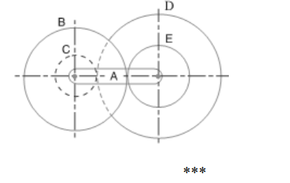 | L3 | CO5 | [10M]
16. | a) | A casting weighing 9 kN hangs freely from a rope which makes 2.5 turns round a drum of 300 mm diameter revolving at 20 r.p.m. The other end of the rope is pulled by a man. The coefficient of friction is 0.25. Determine 1. The force required by the man, and 2. The power to raise the casting | L3 | CO6 | [5M]
 | b) | Explain advantages and disadvantages of chain drive over belt or rope drive | L2 | CO6 | [5M]
17. | a) | Classify and explain the kinematic pairs | L2 | CO1 | [5M]
 | b) | With the help of sketch, describe Robert Mechanisms. | L2 | CO2 | [5M]
18. | a) | A pinion having 30 teeth drives a gear having 80 teeth. The profile of the gears is involute with 20° pressure angle, 12 mm module and 10 mm addendum. Find the length of path of contact, arc of contact and the contact ratio | L3 | CO4 | [5M]
 | b) | Explain about any two gear trains with neat sketches | L3 | CO5 | [5M]
-- 00 -- 00 –

